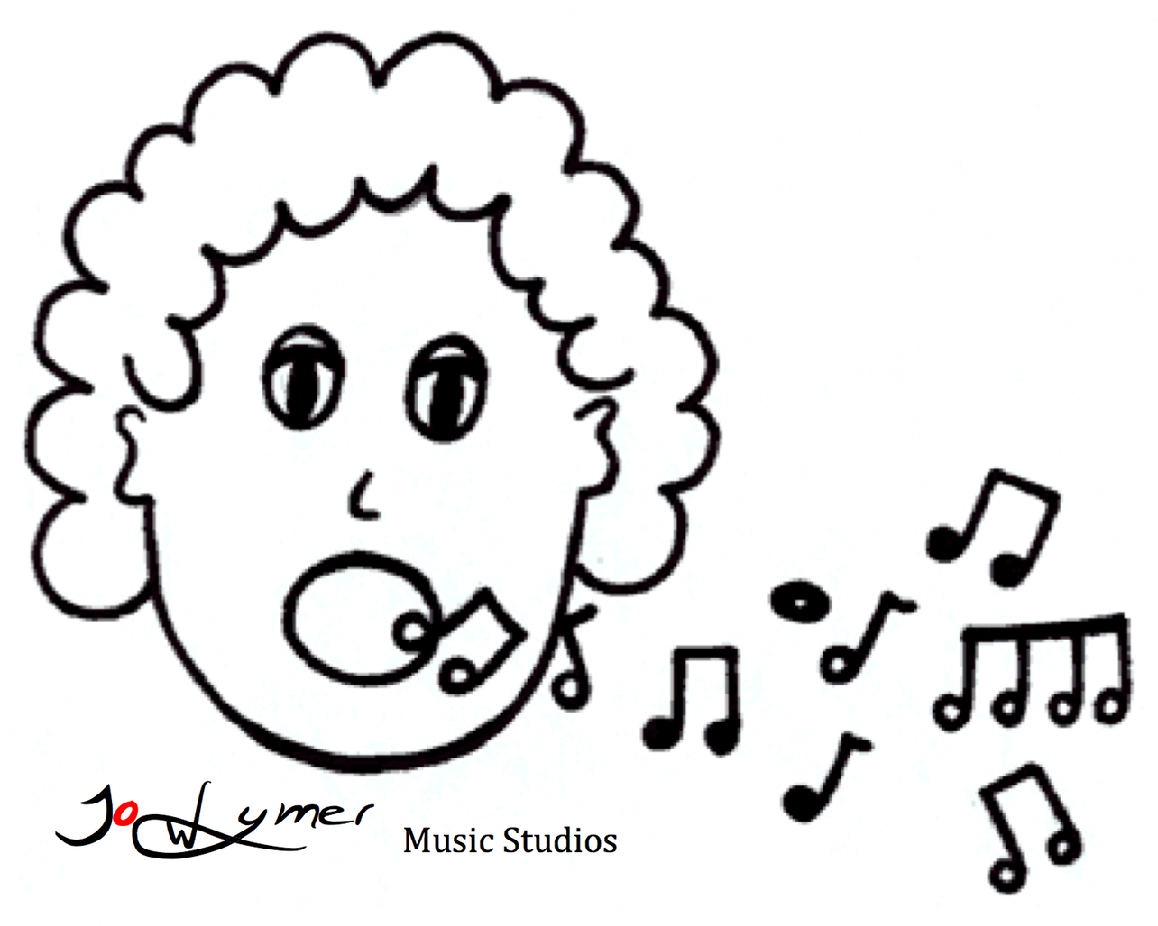
JO WYMER MUSIC STUDIOS
SOCIAL MEDIA CONSENT FORM

Jo Wymer Music Studios would like permission to use photos and/or video of your student’s performances at showcases or recitals. The intent is to showcase their talents and the work and progress that has taken place under my tutelage.

The media will be used on Facebook and www.jowymermusicstudios.com only unless otherwise authorized. Please check the appropriate section and please sign and date. You can bring back this form at your next session.

DECLARATION (check the appropriate one)

_________ I grant JO WYMER MUSIC STUDIOS the permission to use photos and/or video of my student’s performance (s) for the intended use described above.

__________ I do not grant JO WYMER MUSIC STUDIOS the permission to use photos and/or of my student’s performance (s) for the intended use described above.

Date: ______________________ STUDENT NAME:________________________________

Parent’s Name (please print)_____________________________________________________

Parent Signature (if under 18) ____________________________________________________

Student Signature (if 18 or older) _________________________________________________

